|  |
| --- |
| Close-up image showing the leaf-sides of two oversized books side-by-side on a bookshelf, with additional books in soft focus background |
| Azure Active Directory  Integration Guide with Web Access Management using F5 BIG-IP Access Policy Manager (APM) |
| |  |  |  | | --- | --- | --- | |  |  |  | |

Contents

Integration Guide with Web Access Management using F5 BIG-IP Access Policy Manager (APM) 0

Introduction 1

Pre-requisites 2

Access guided configuration 3

Guided Configuration 5

Header Based Application 5

Setting up Azure Active Directory Integration 5

Configuring F5 BIG-IP 12

Testing the Integration 24

Appendix 27

SAML – F5 BIG-IP Variable mappings 27

Adding Custom Claims 29

# Introduction

This guide covers Integration of Azure Active Directory and F5 BIG-IP APM (Access Policy Manager). The document describes ability to secure publish the application using F5 and be able to securely Integrate with Azure AD Platform leveraging some of the core functionalities like Azure AD Conditional Access and Identity Protection Services.

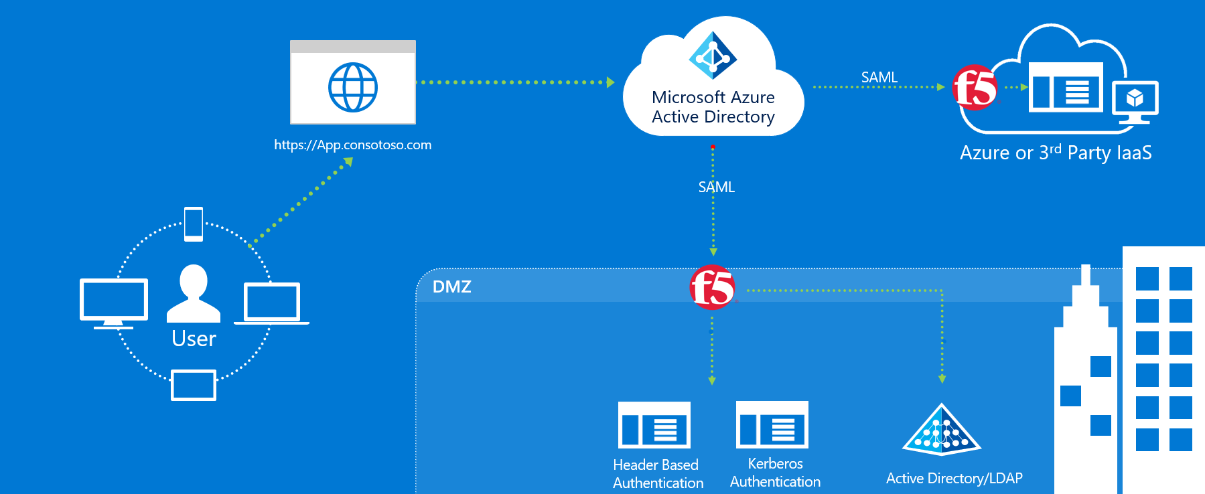

The Above Integration allows enterprises to leverage F5 with Azure AD to cover the both Modern authentication and Kerberos and header Authentication using Azure Active Directory as control Plane.

|  |  |  |  |
| --- | --- | --- | --- |
| **SNo** | **Scenarios** | **Azure AD** | **F5 BIG-IP** |
| 1 | Header Based Authentication | SAML IDP - Azure Conditional Access / Identity Protection Services | SAML SP - Maps SAML Assertion to HTTP Headers for Application consumption |
| 2 | Kerberos Authentication | SAML IDP - Azure Conditional Access / Identity Protection Services | SAML SP - Performs KCD for Single Sign on for Kerberos Applications |

# Pre-requisites

1. Deploying the joint solution requires the following license:

* F5 BIG-IP® Best bundle (or)
* F5 BIG-IP Access Policy Manager™ (APM) standalone license
* F5 BIG-IP Access Policy Manager™ (APM) add-on license on an existing BIG-IP F5 BIG-IP® Local Traffic Manager™ (LTM).
* In addition to the above license, the F5 system may also be licensed with:
  + A URL Filtering subscription to use the URL category database
  + An F5 IP Intelligence subscription to detect and block known attackers and malicious traffic
  + A network hardware security module (HSM) to safeguard and manage digital keys for strong authentication

1. F5 BIG-IP system is provisioned with APM modules (LTM is optional)
2. Although optional, it is highly recommended to Deploy the F5 systems in a [sync/failover device group](https://techdocs.f5.com/kb/en-us/products/big-ip_ltm/manuals/product/big-ip-device-service-clustering-administration-14-1-0.html) (S/F DG), which includes the active standby pair, with a floating IP address for high availability (HA). Further interface redundancy can be achieved using the Link Aggregation Control Protocol (LACP). LACP manages the connected physical interfaces as a single virtual interface (aggregate group) and detects any interface failures within the group.
3. For Kerberos applications, an on-premises AD service account for constrained delegation. Refer to [F5 Documentation](https://support.f5.com/csp/article/K43063049) for creating a AD delegation account.

# Access guided configuration

‘Access guided configuration’ is supported on F5 TMOS version 13.1.0.8 and above. If your BIG-IP system is running a version below 13.1.0.8, please refer to the **Advanced configuration** section

Access guided configuration presents a completely new and streamlined user experience. This workflow-based architecture provides intuitive, re-entrant configuration steps tailored to the selected topology.

Before proceeding to the configuration, upgrade the guided configuration by downloading the latest use case pack from [downloads.f5.com](https://downloads.f5.com). To upgrade, follow the below procedure

Note – The screenshots below are for the latest released version (BIG-IP 15.0 with AGC version 5.0). The configuration steps below are valid for this use case across from 13.1.0.8 to the latest BIG-IP version.

* On the F5 BIG-IP Web UI, click on ***Access >> Guide Configuration***.
* On the **Guided Configuration** page, click on **Upgrade Guide Configuration** click on the top left-hand corner.

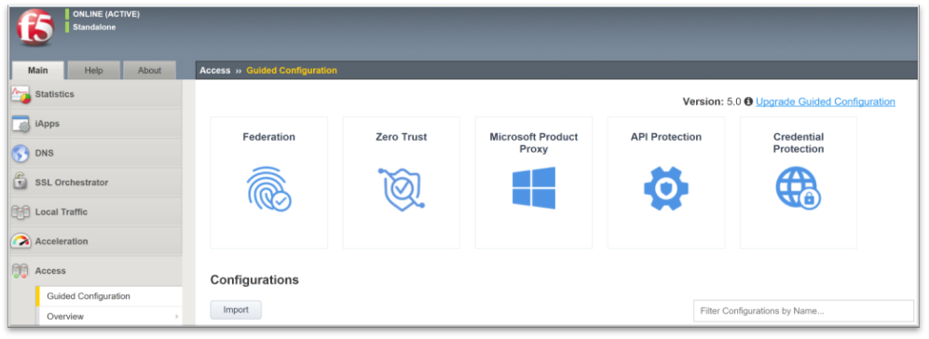

* On the Upgrade Guide Configuration pop screen, select the downloaded use case pack and click on **Upgrade and Install** button.

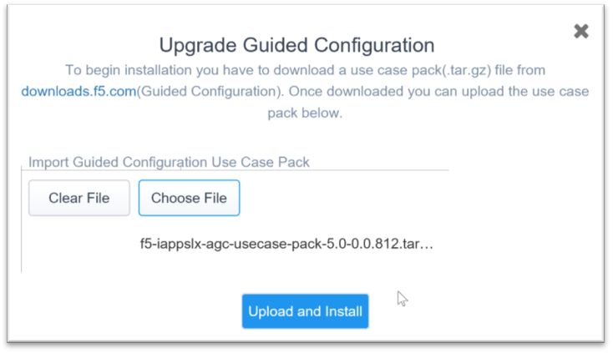

* When upgrade is completed, click on the **continue** button.

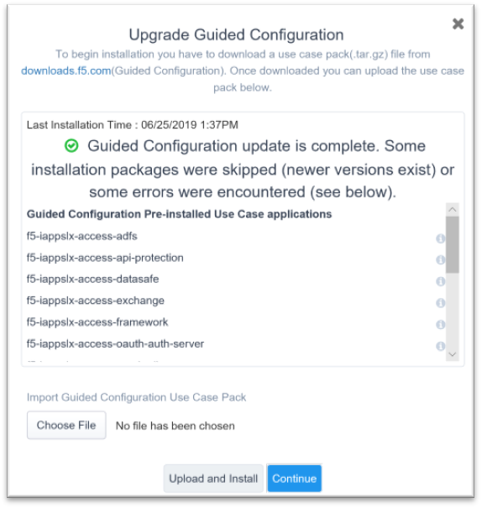

# Guided Configuration

## Header Based Application

### Setting up Azure Active Directory Integration

1. Select **Enterprise Application Blade** and in the **Add from the gallery** search **F5.**
2. Specify the Name for your App
3. Click on **Add**

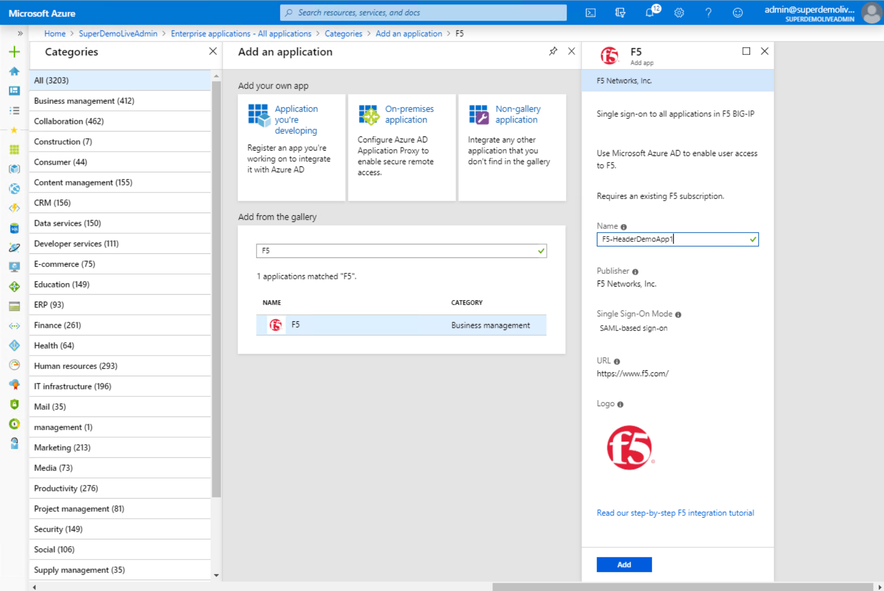

**Configure Single Sign-on**

1. Goto **Single sign-on**
2. Specify SAML as the Single Sign-on method

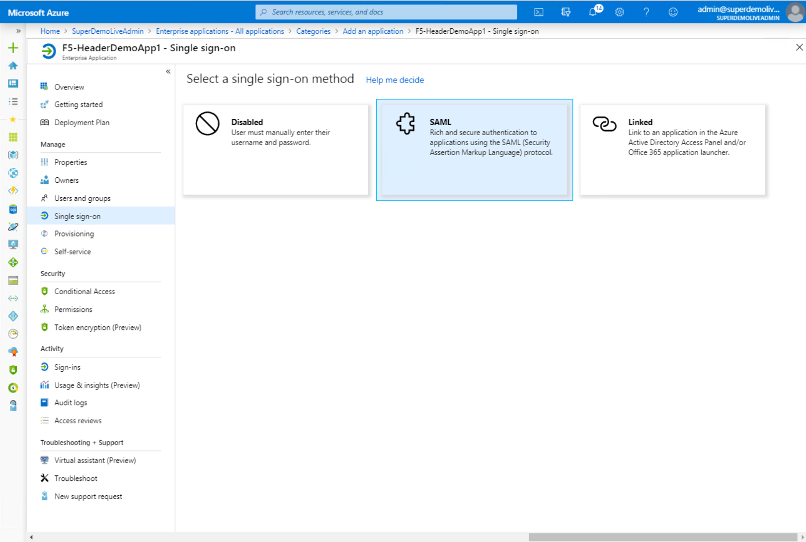

**Complete the Basic SAML Configuration Section**

1. Specify the **Identifier (Entity ID)**
2. Specify the **Reply URL (Assertion Consumer Service URL)** Generally same as above
3. Click **Save**

**Note**: in the example both values are <https://headerapp.superdemo.live> which is the F5 application URL

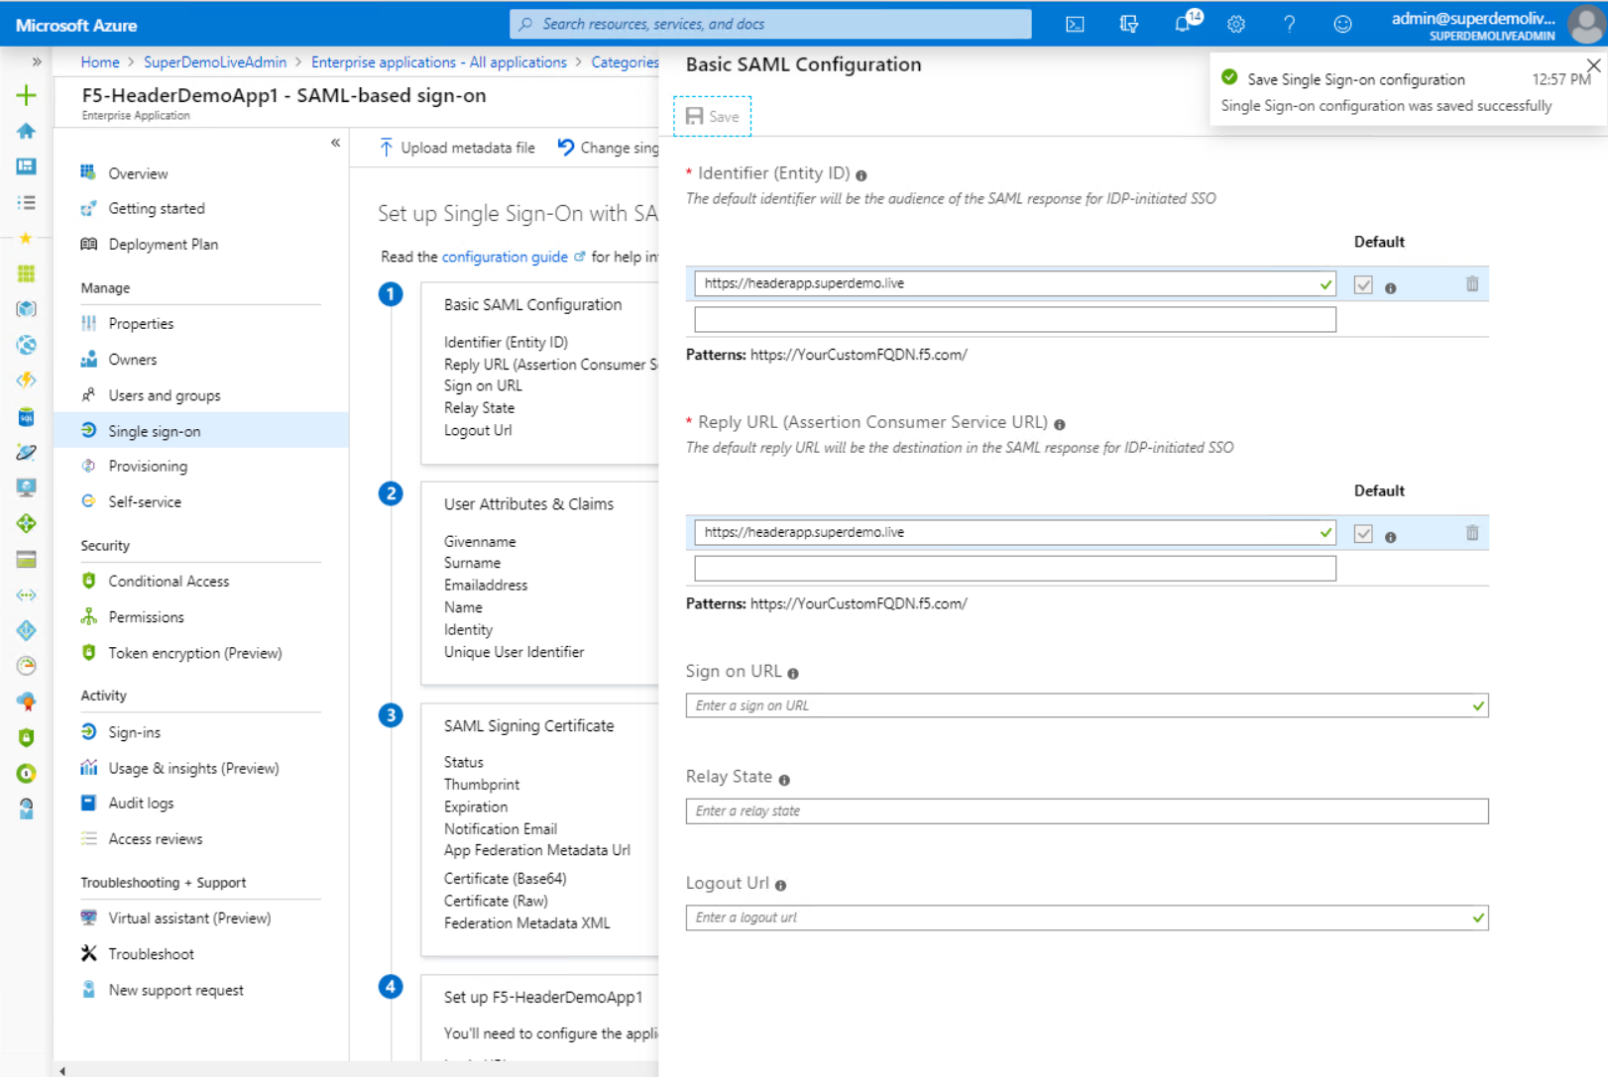

**SAML Signing Certificate** (using the links in Section 3 in the below picture)

1. Download the **Federation Metadata XML**
2. Download the **Certificate (Base64)**

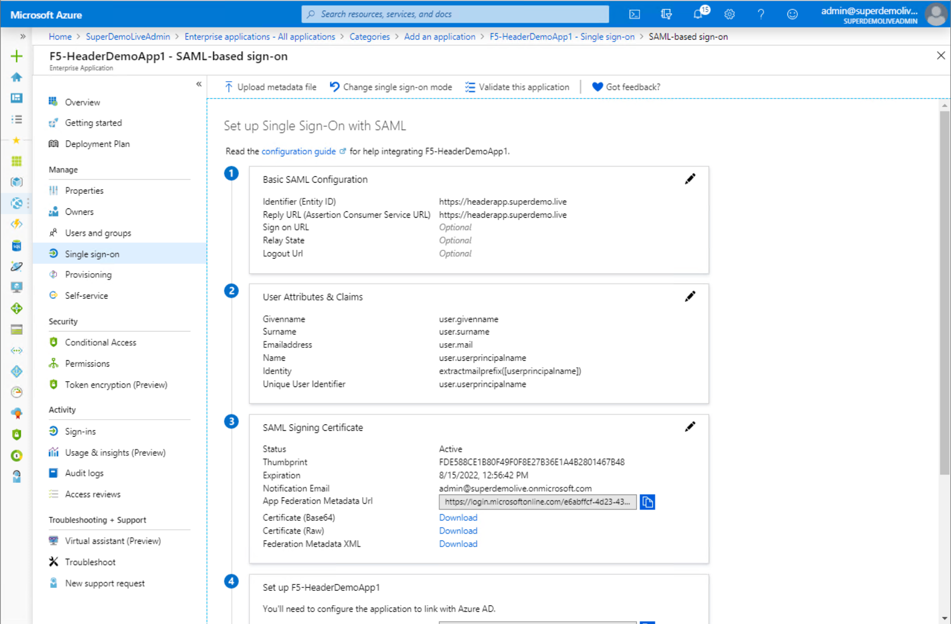

**Assign users and groups**

1. Click on the **Users and Groups** blade and Specify the users entitled for the Applications.

(in the example below a group called TechUsers)

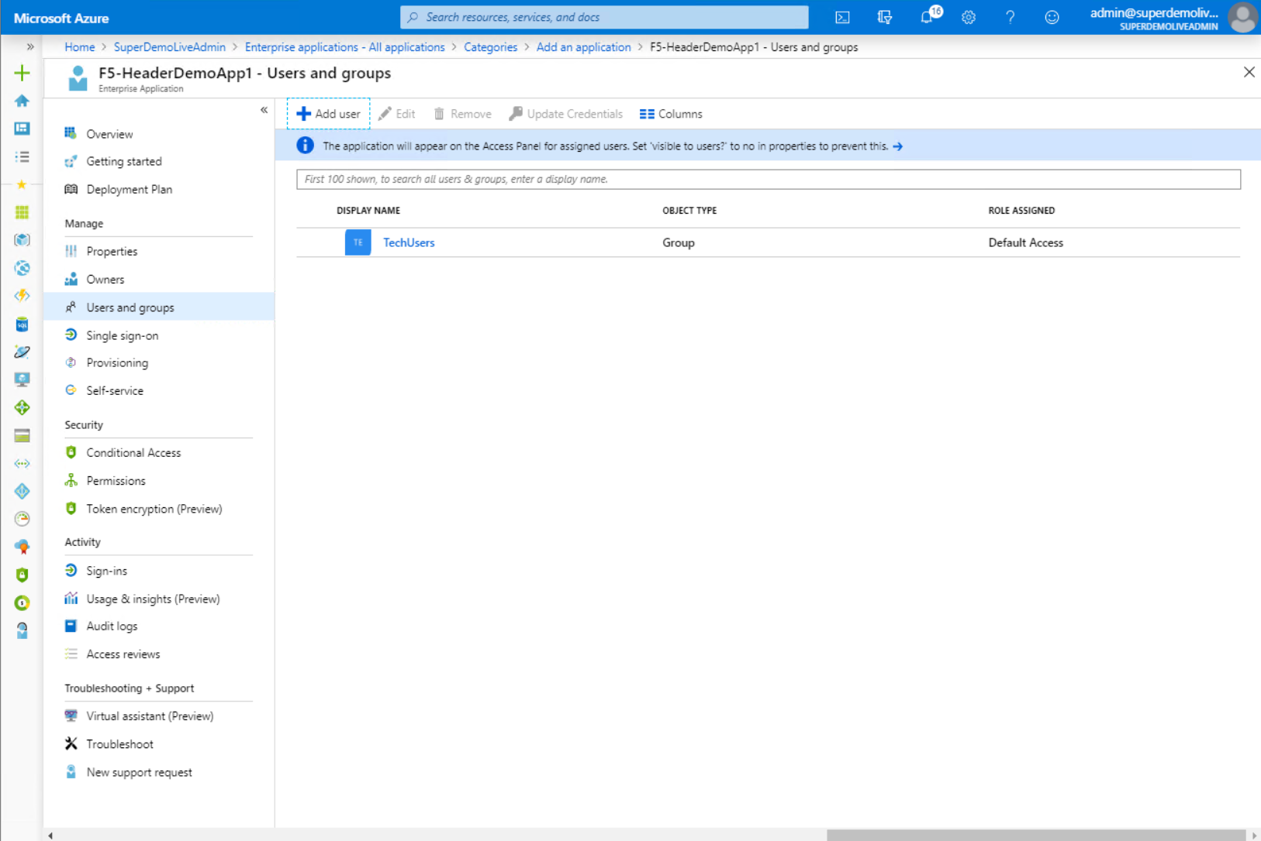

**Setup Conditional Access Policy**

1. Click on **Conditional Access**
2. Click on **New Policy**

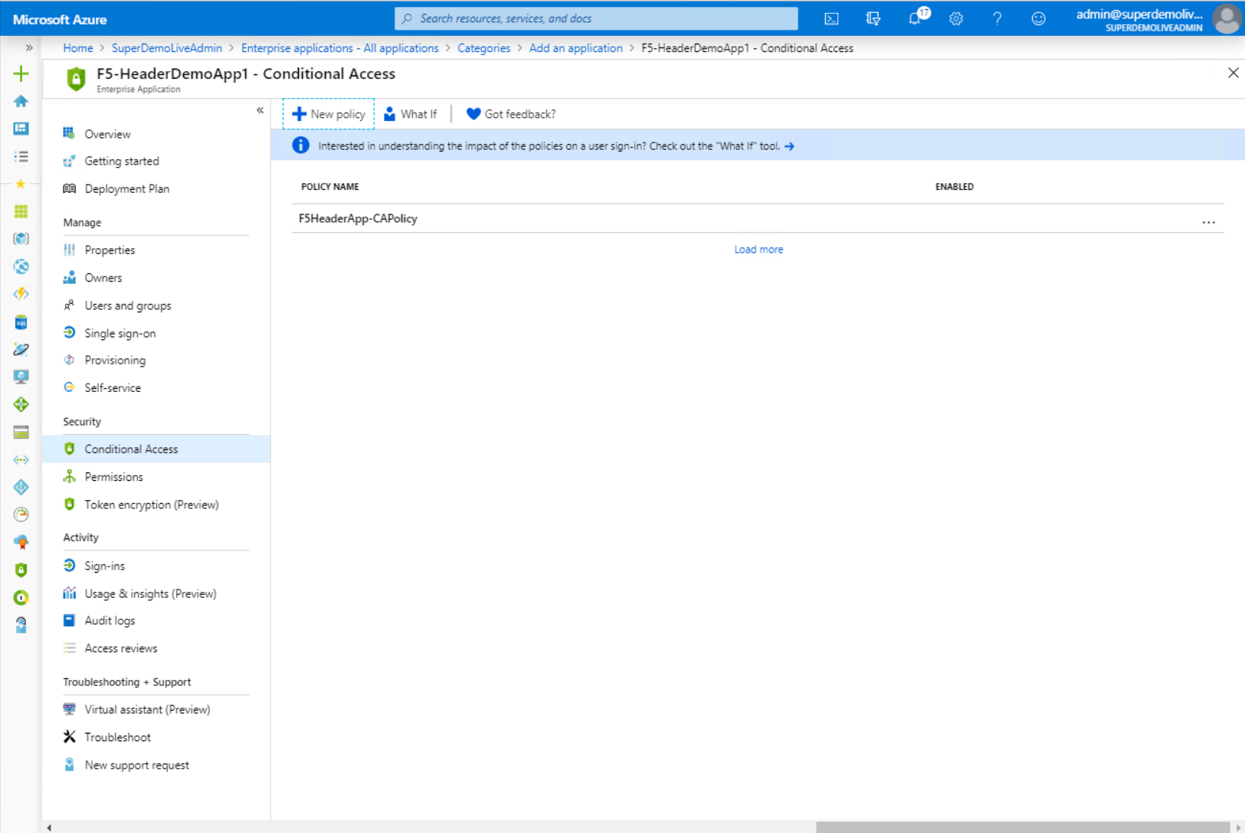

**Define Controls**

1. You can now see your F5 App as a resource for CA Policy and apply any conditional access including Multifactor Auth, Device based access control or Identity Protection Policy,

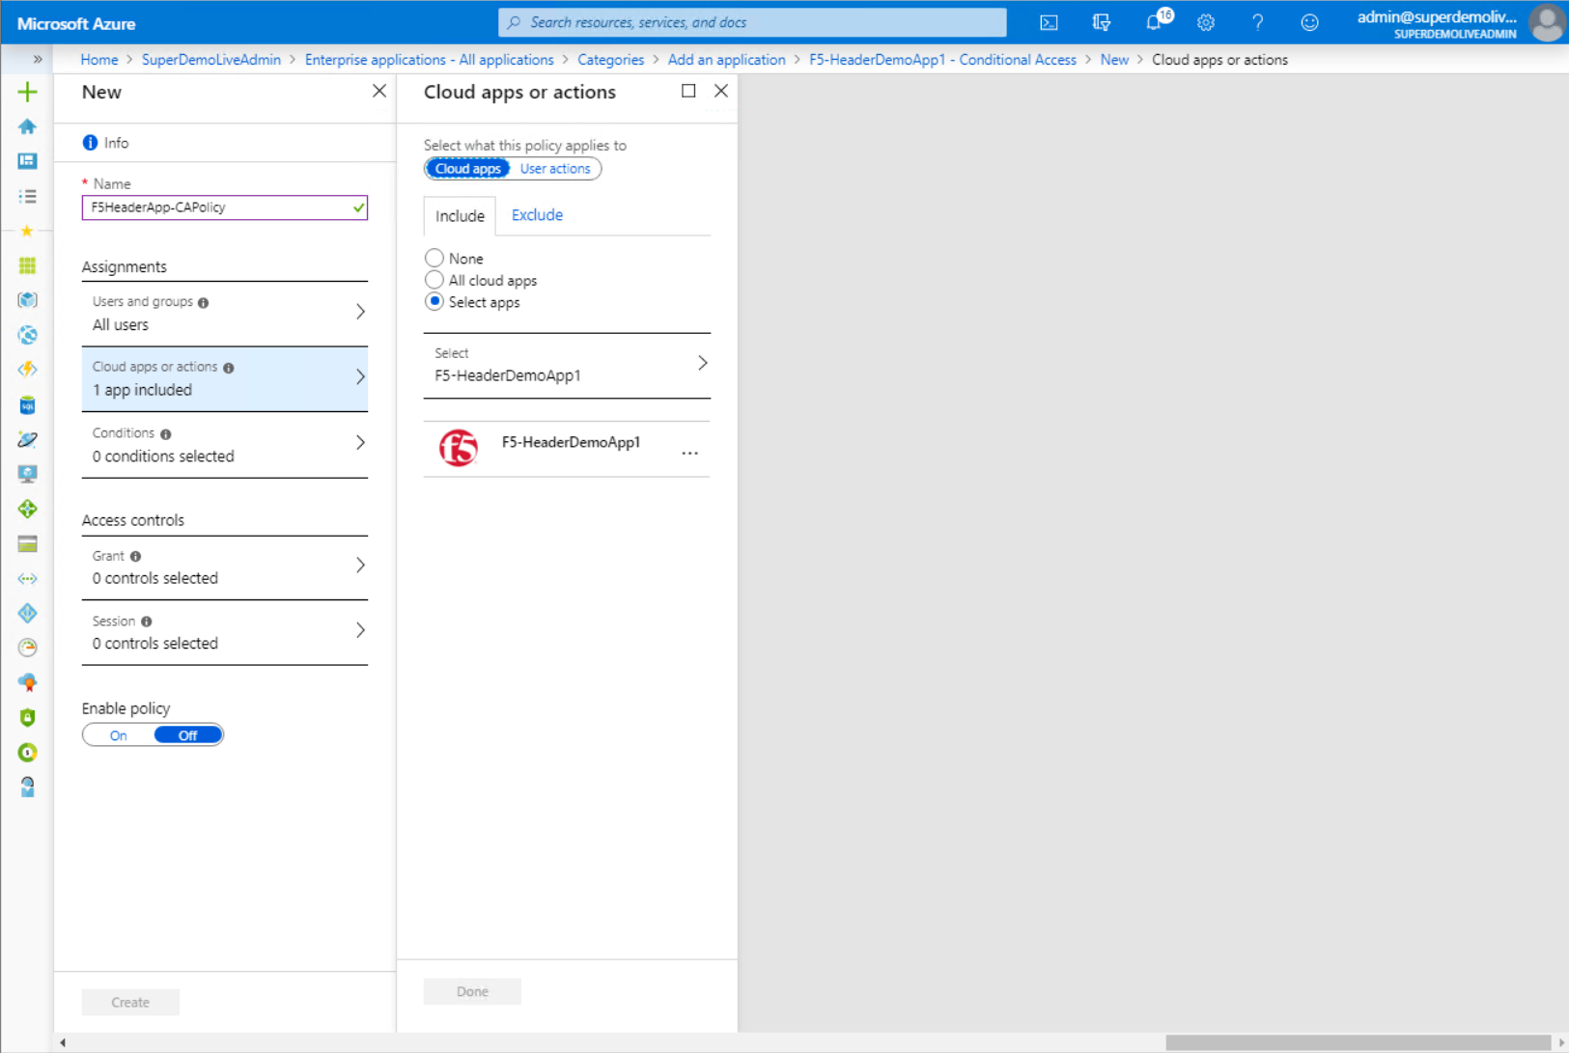

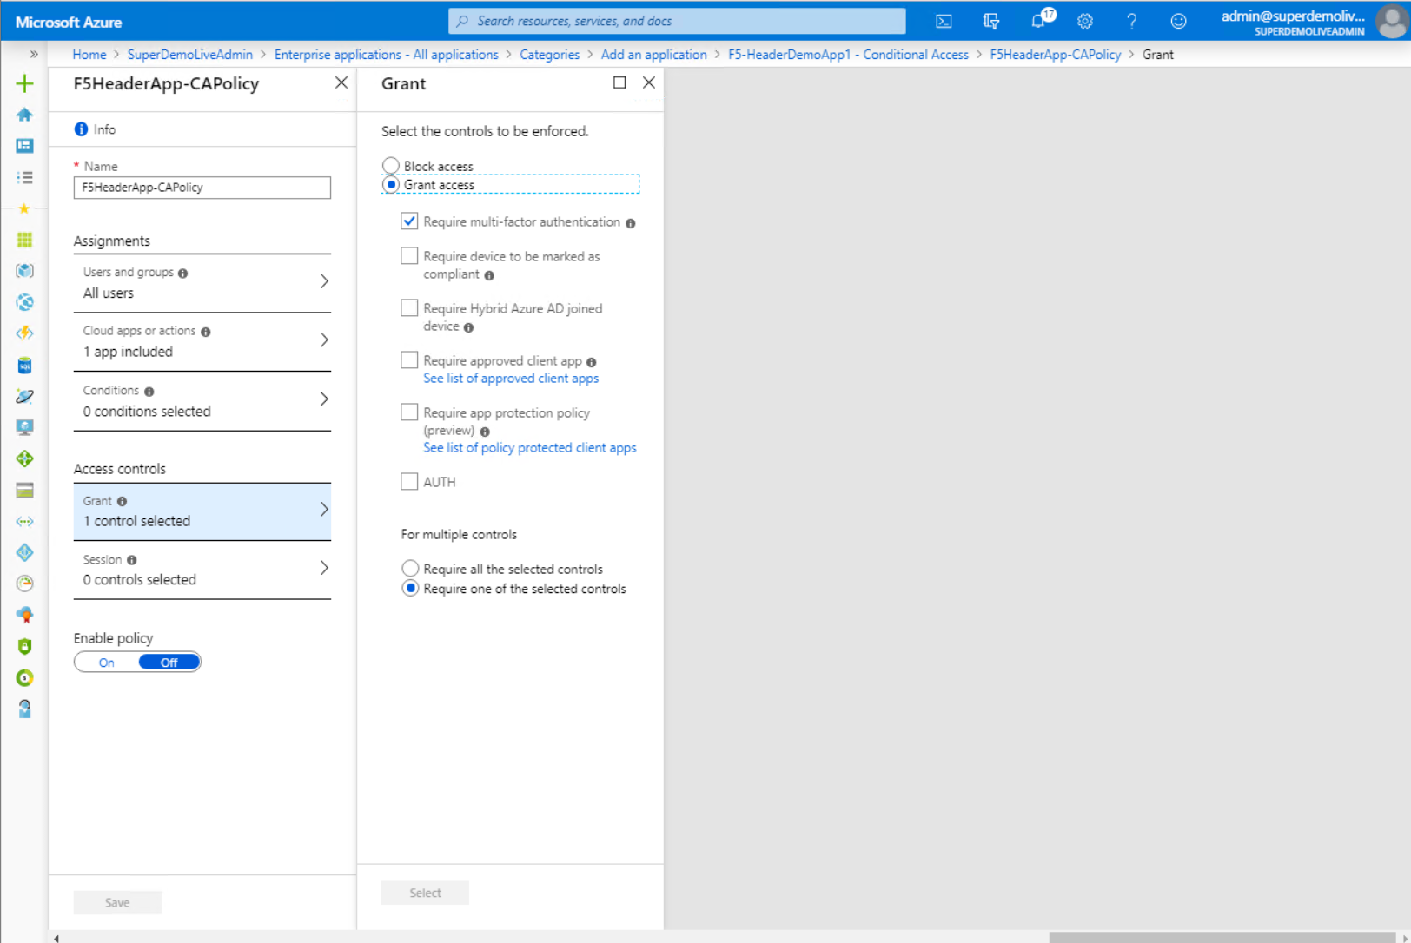

### Configuring F5 BIG-IP

**Configuring F5 BIG-IP**

You will need to import the Metadata Certificate into the F5 which will be used later in the setup process.

1. Navigate to **System** > **Certificate Management** > **Traffic Certificate Management** > **SSL Certificate List**
2. Select Import from the right-hand corner.
3. Specify a **Certificate Name** (will be referenced Later in the config)
4. In the **Certificate Source**, select Upload File specify the certificate downloaded from Azure while configuring SAML Single Sign on
5. Click **Import**

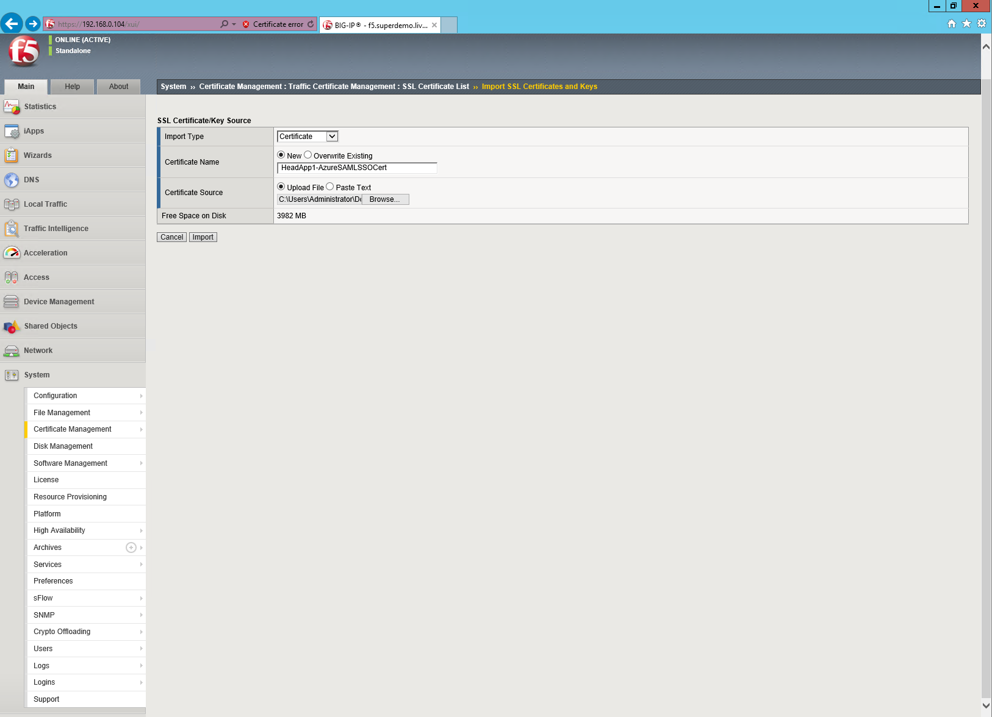

Additionally, you will require SSL Certificate for the Application Hostname.

1. Navigate to **System** > **Certificate Management** > **Traffic Certificate Management** **> SSL Certificate List.**
2. Select Import from the right-hand corner.
3. **Import Type** will be **PKCS 12(IIS)**
4. Specify a **Key Name** (will be referenced Later in the config) and the specify the PFX file
5. Specify the **Password** for the PFX
6. Click **Import**

Note: In the example our app name is **Headerapp.superdemo.live**, we are using a Wild Card Certificate our keyname is WildCard-SuperDemo.live

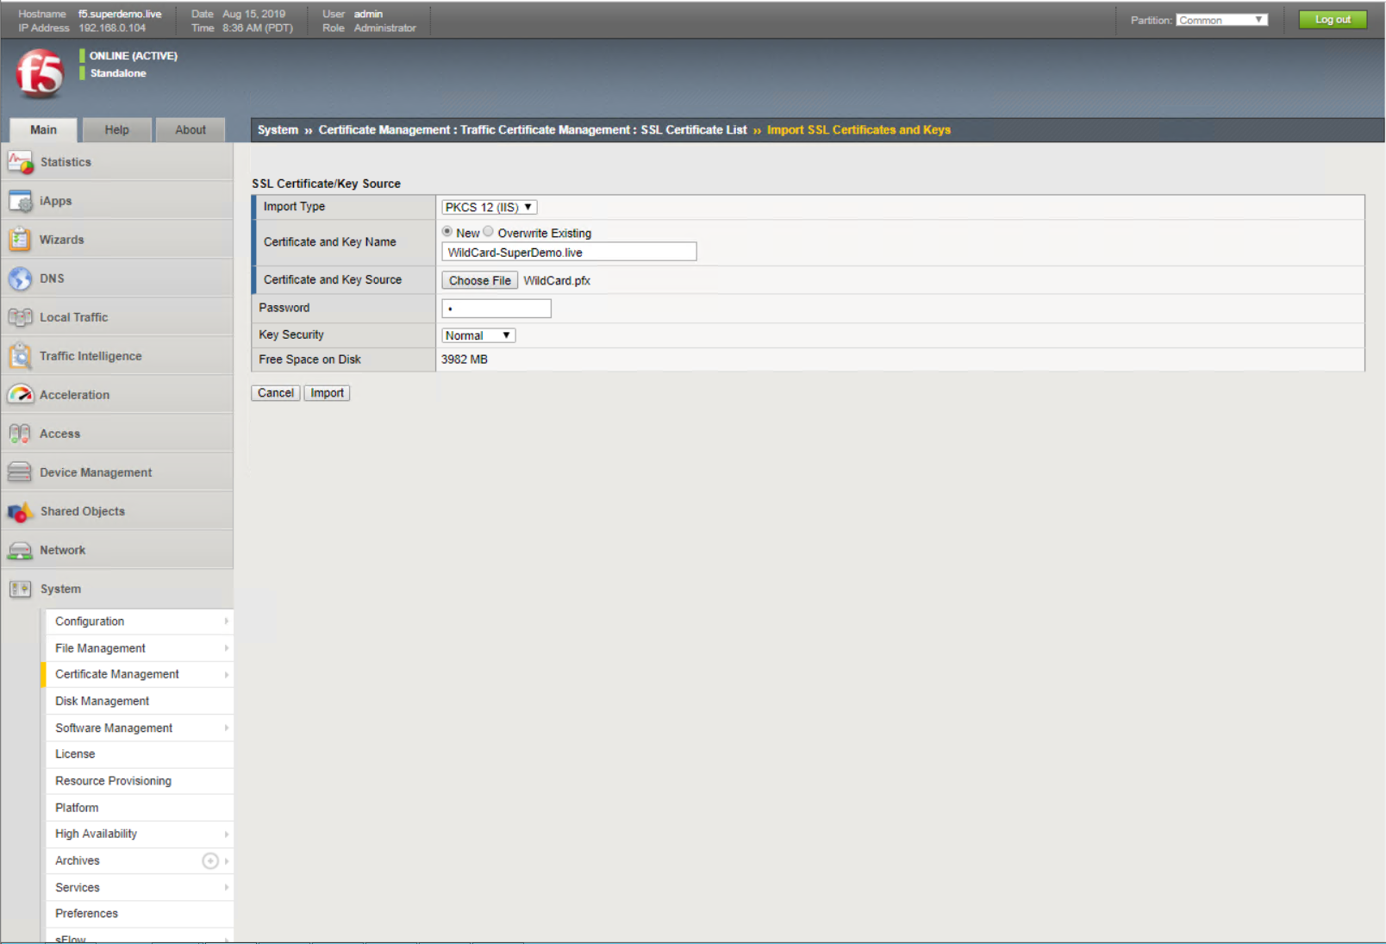

We will use the Guided Experience to setup the Azure AD Federation and Application Access.

1. Go to – F5 BIG-IP **Main** and select **Access** > **Guided Configuration** > **Federation** > **SAML Service Provider**
2. click **Next**

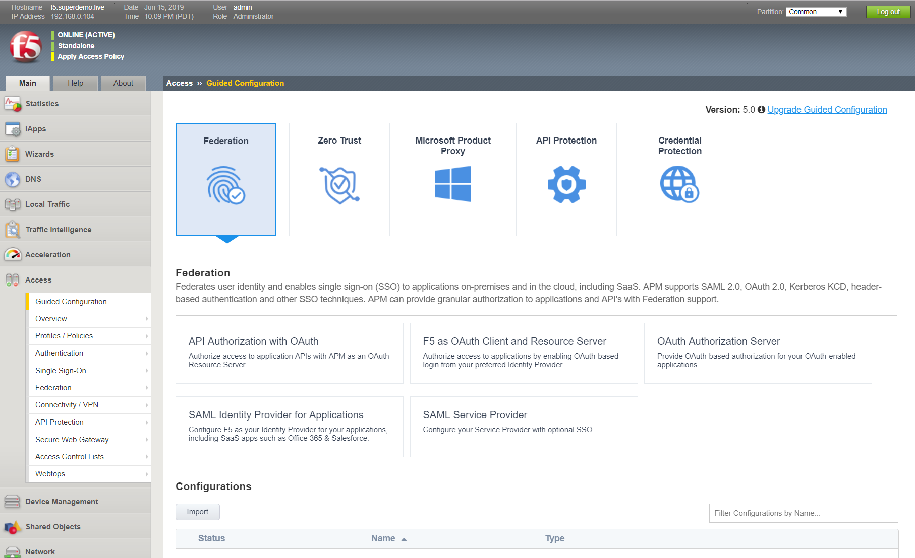

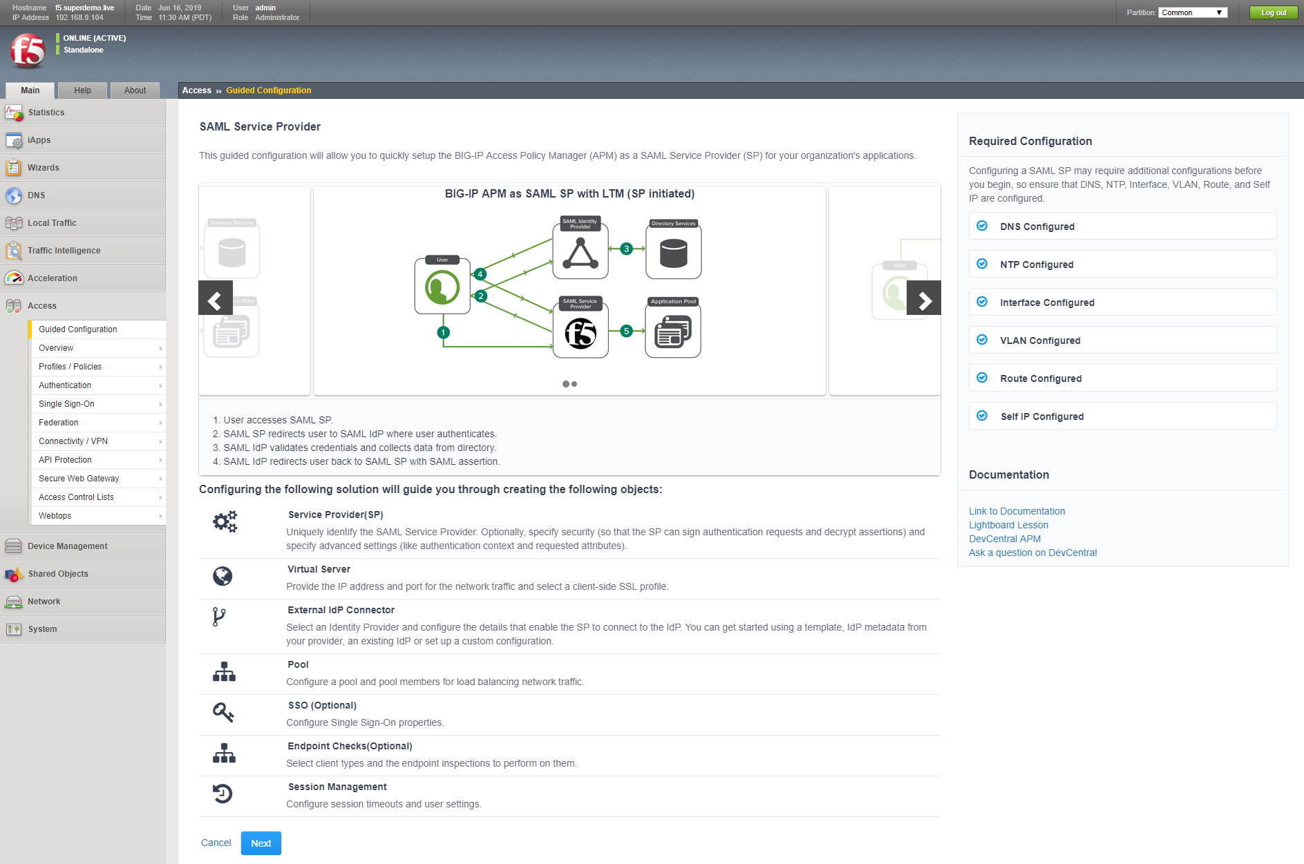

Select Next to begin configuration.

**Service Provider Properties**

1. Provide a Configuration Name
2. Specify the Entity ID (same as what you configured on the Azure AD Application Configuration)
3. Specify the Host name.
4. Add a Description for reference
5. Accept the remaining default entries and select and then click Save & Next.

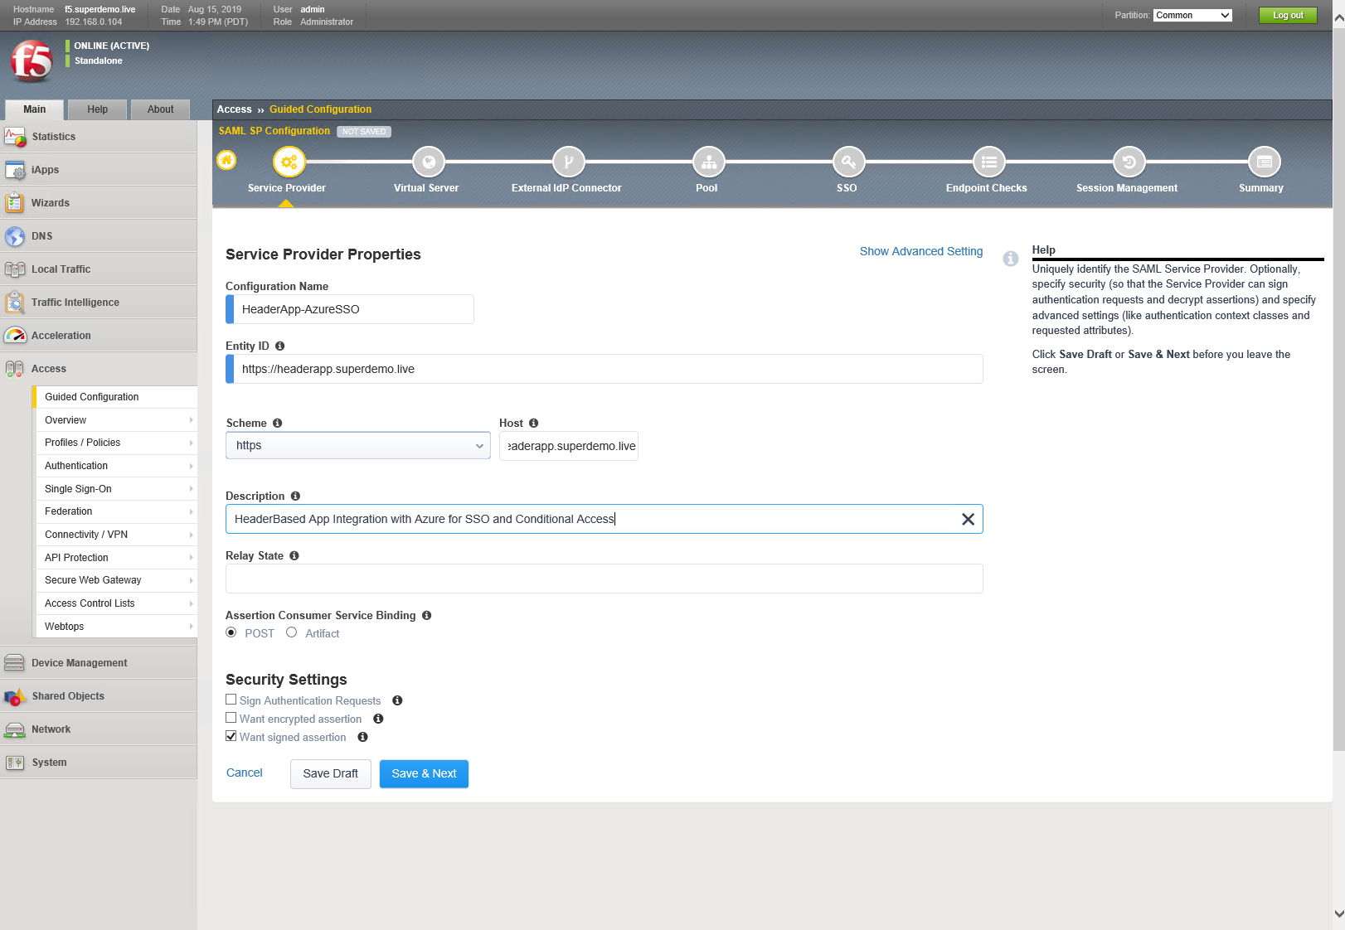

**Virtual Server Properties**

In this example we are creating a new Virtual Server as 192.168.30.20 with port 443.

1. Specify the Virtual Server IP address in the **Destination Address**.
2. Select the **Client SSL Profile**, select Create new
3. Specify previously uploaded application certificate, (the wild card certificate in this example) and the associated key, and then click **Save & Next**.

Note: in this example our Internal webserver is running on port 888 and we want to publish it with 443.

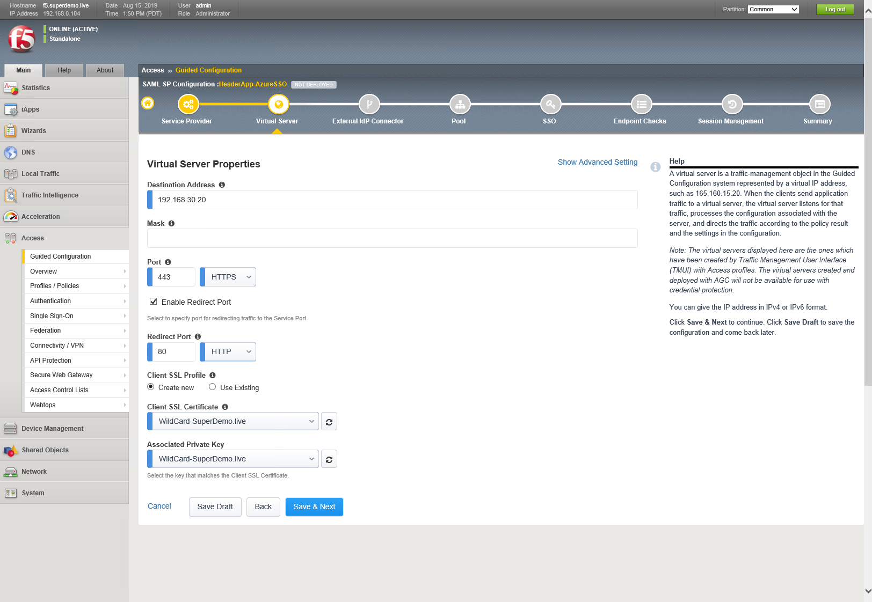

**External Identity Provider Connector Settings**

1. Under **Select method to configure your IdP connector**, specify **Metadata**, click on Choose File and upload the Metadata XML file downloaded earlier from Azure AD.
2. Specify a unique **Name** for SAML IDP connector.
3. Choose the **Metadata Signing Certificate** which was upload earlier
4. click **Save & Next**

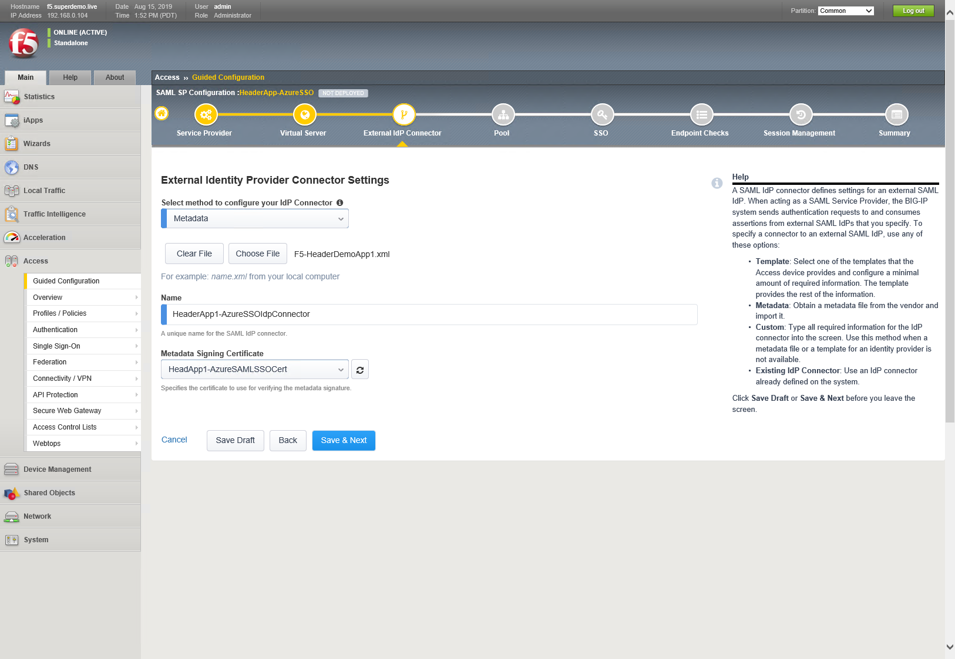

**Pool Properties**

1. Under **Select a Pool**, specify **Create New** (alternatively select a pool it already exists)
2. Let other value be default
3. Under Pool Servers, type the IP Address under **IP Address/Node Name**
4. Specify the **Port**
5. Click **Save & Next**

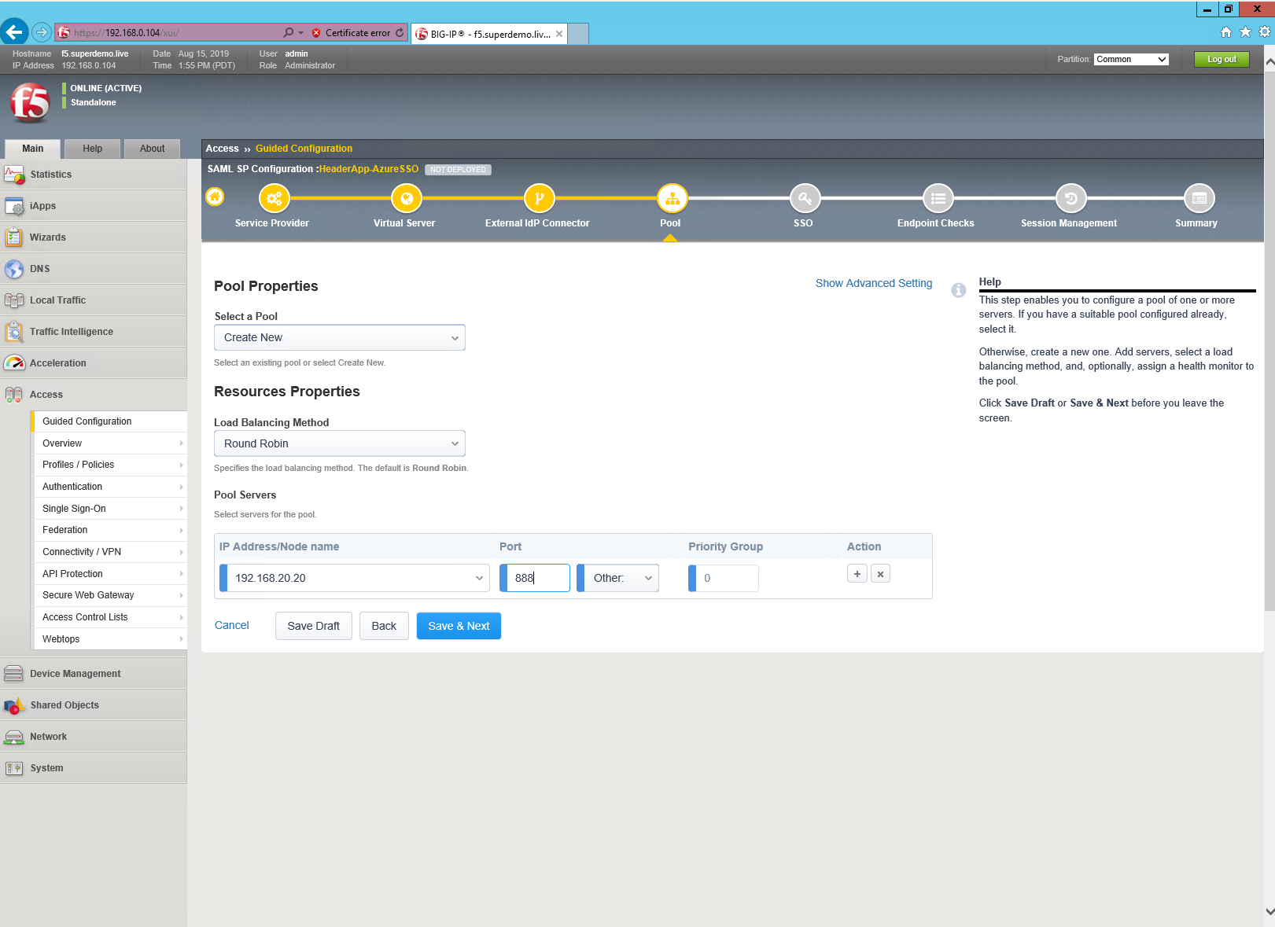

**Single Sign-on Settings**

1. On the Single Sign-On Settings screen, select Enable Single Sign-On
2. Under Selected Single Sign-On Type choose **HTTP header-based**
3. Replace **session.saml.last.Identity** with **session.saml.last.attr.name.Identity** under Username Source ( this variable it set using claims mapping in the Azure AD )
4. Under SSO Headers
   * **HeaderName**  : **MyAuthorization**
   * **Header Value : %{session.saml.last.attr.name.Identity}**
5. Click Save & Next.

Refer Appendix for complete list of variables and values. You can add more headers as required.

Note: Account Name Is the F5 Delegation Account Created ( Check F5 Documentation)

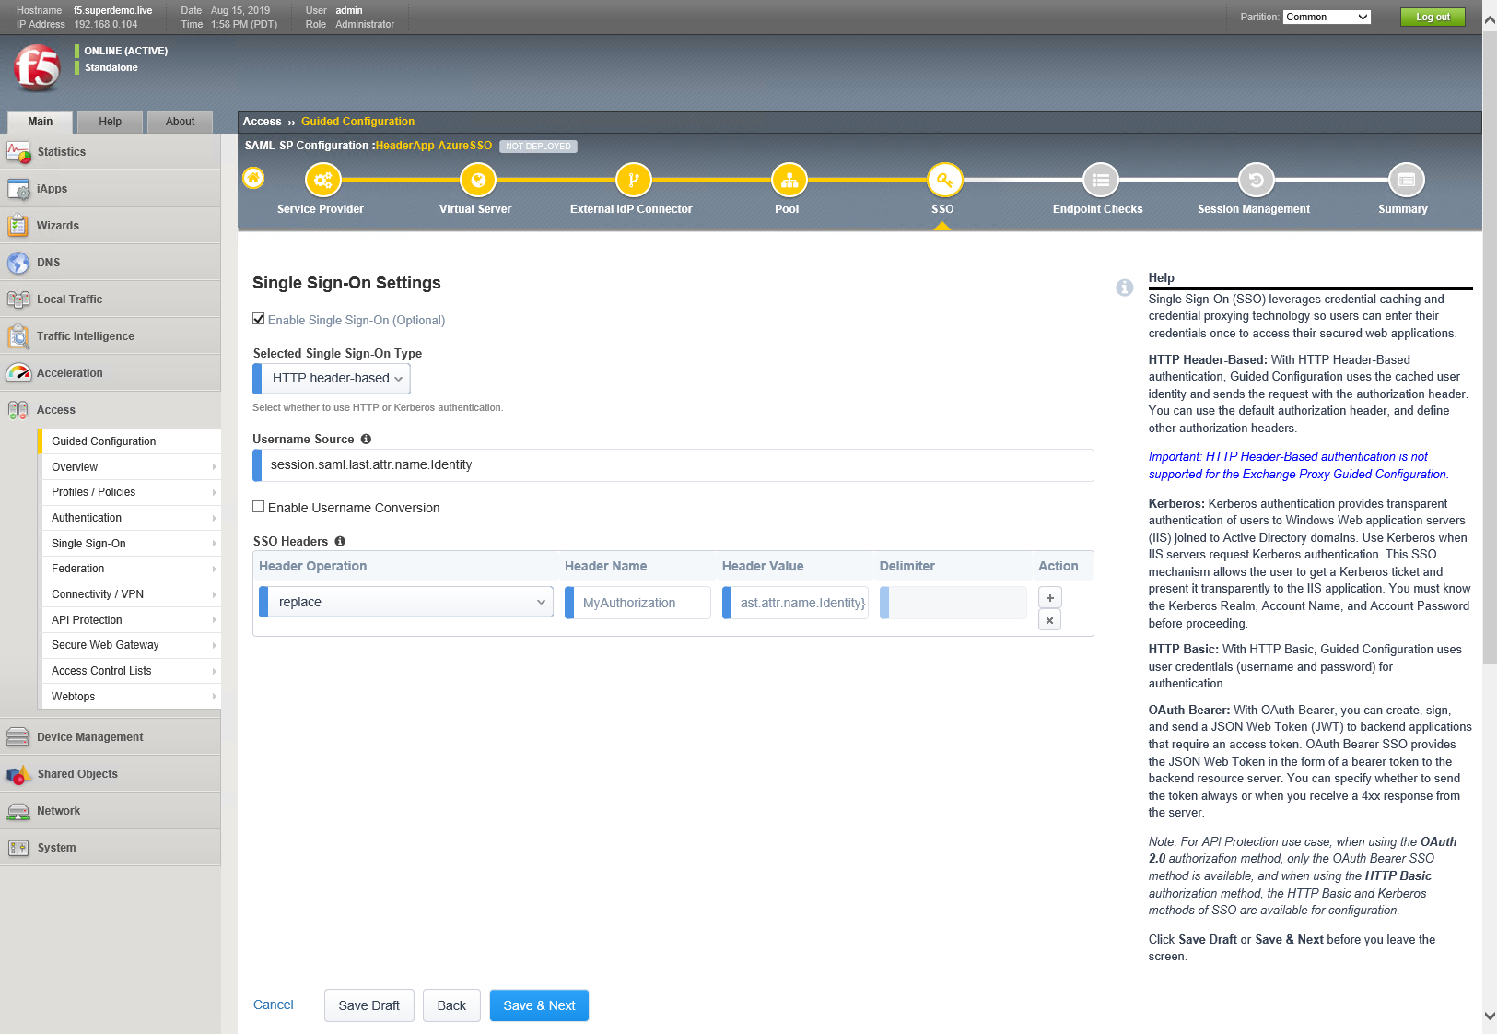

**Endpoint Check Properties**

For purposes of this guidance, we will skip endpoint checks. Refer to F5 documentation for details.

* select Save & Next.

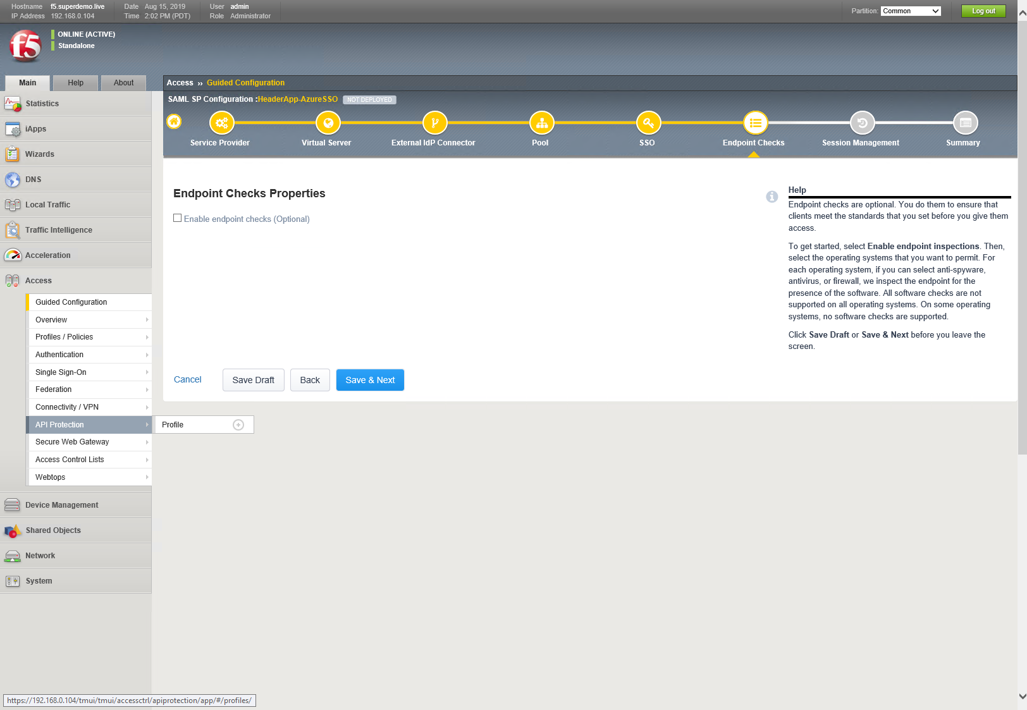

**Timeout Settings**

1. accept the defaults and click Save & Next.
2. Consult F5 documentation for details regarding SAML session management settings.

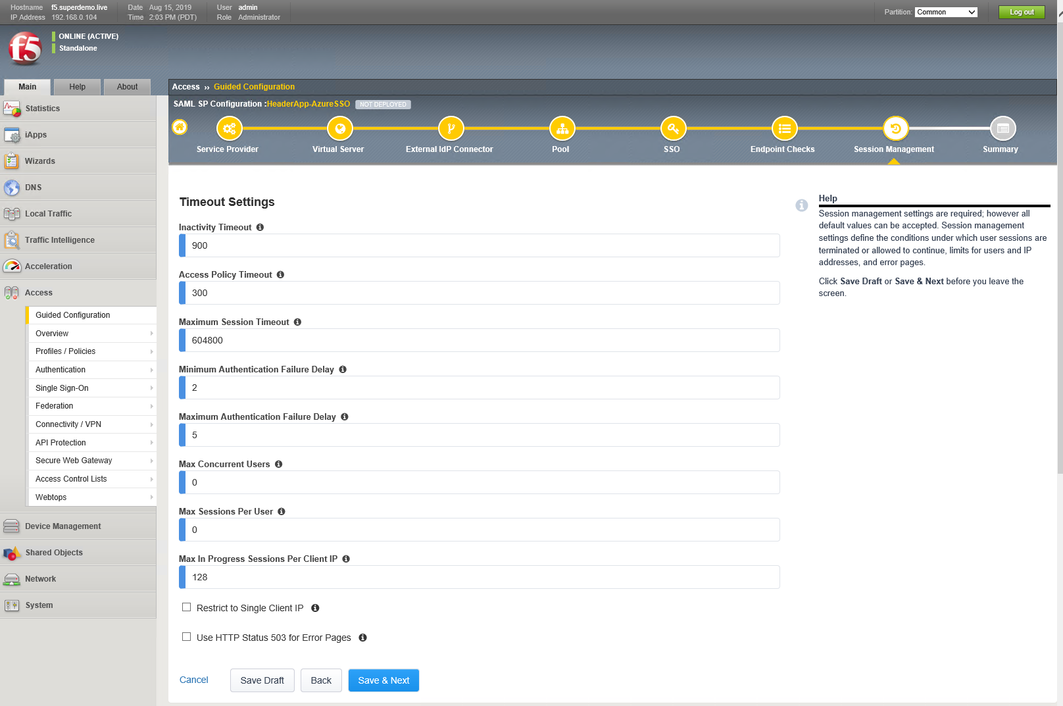

Review the summary screen and select ‘Deploy’ to configure the BIG-IP.

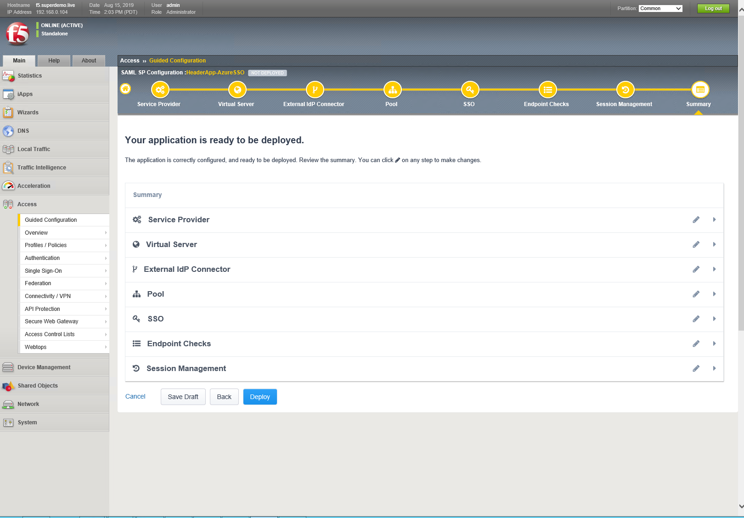

Once the application has been click on Finish.

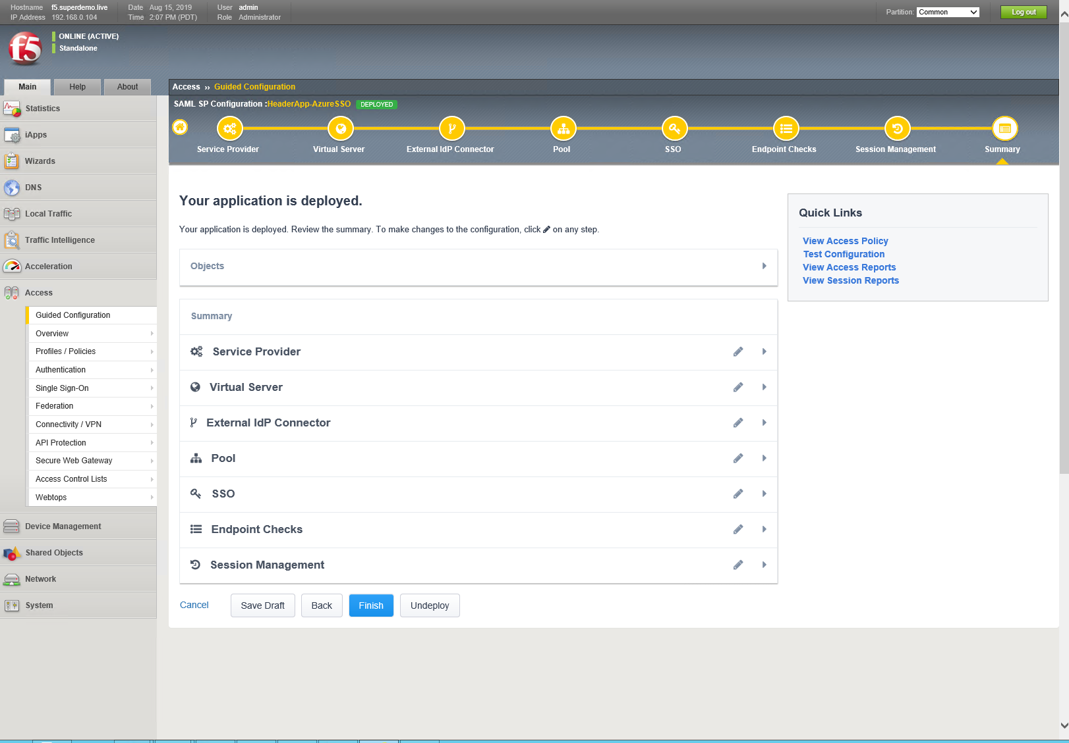

Testing the Integration

Navigate to the https://kerbapp.superdemo.live, you will be redirected to Azure Active Directory Login Page

### Testing the Integration

Navigate to the App, [**https://headerapp.superdemo.live**](https://headerapp.superdemo.live), Notice it is redirected to Azure AD

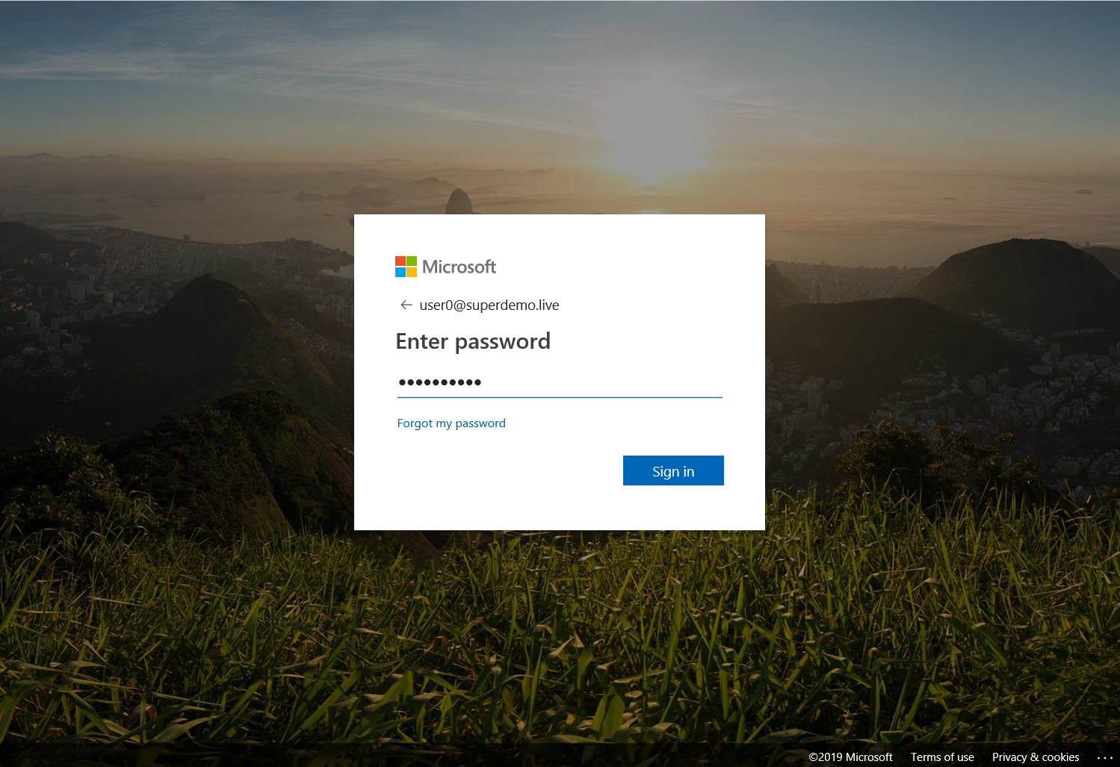

The Application Sample prints all the headers and you can see **HTTP_MYAUTHORIZATION** header was inserted with the appropriate value

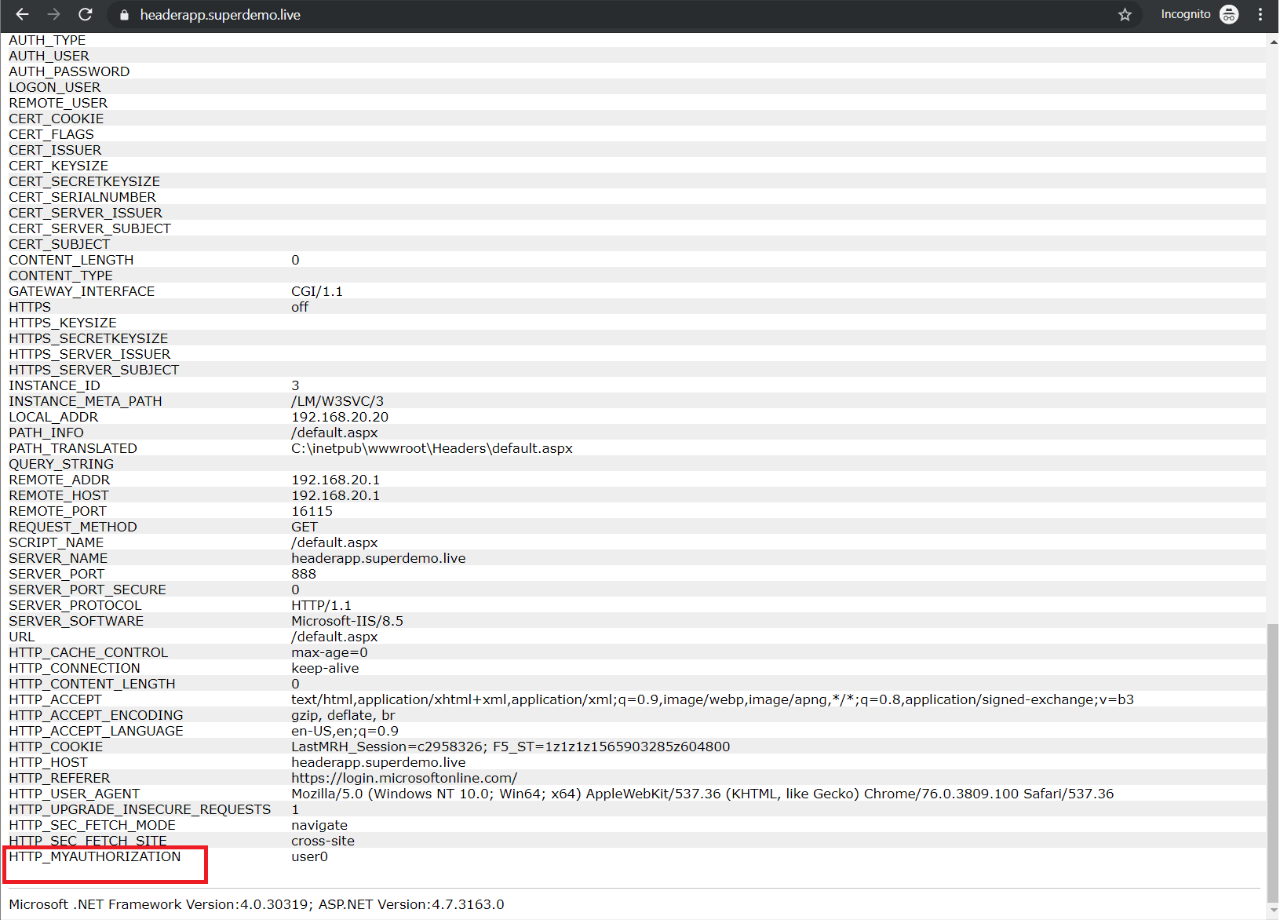

Alternatively, you can simply access the Application from myapps.microsoft.com Portal.

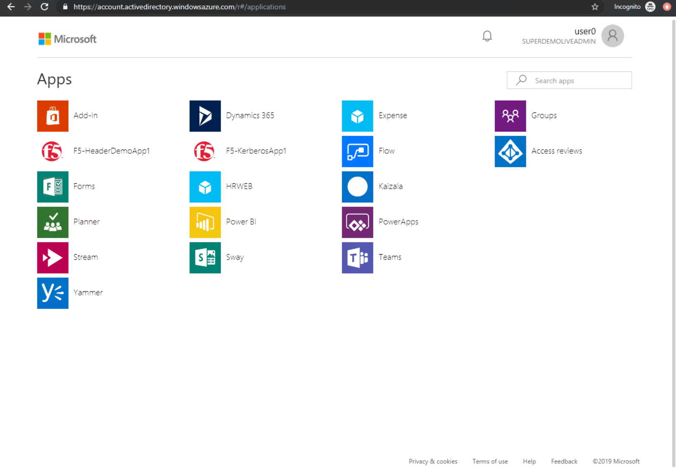

# Appendix

## SAML – F5 BIG-IP Variable mappings

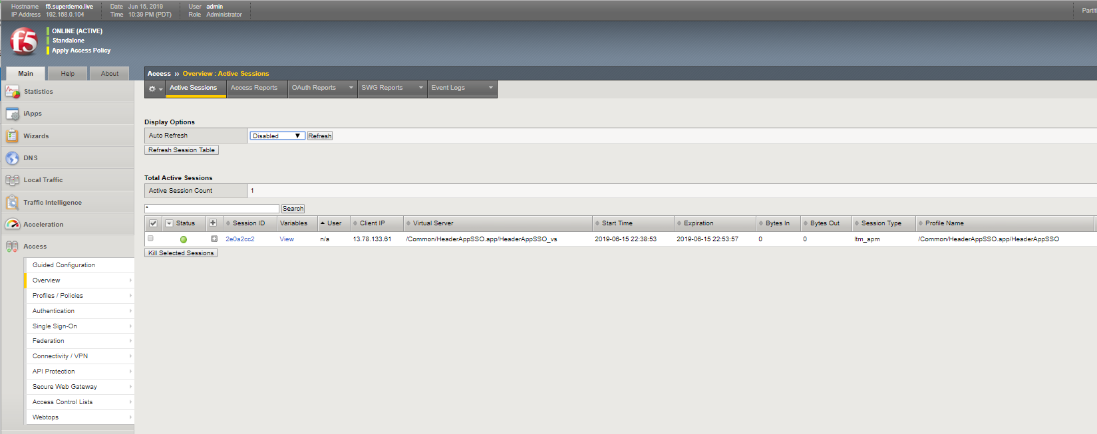

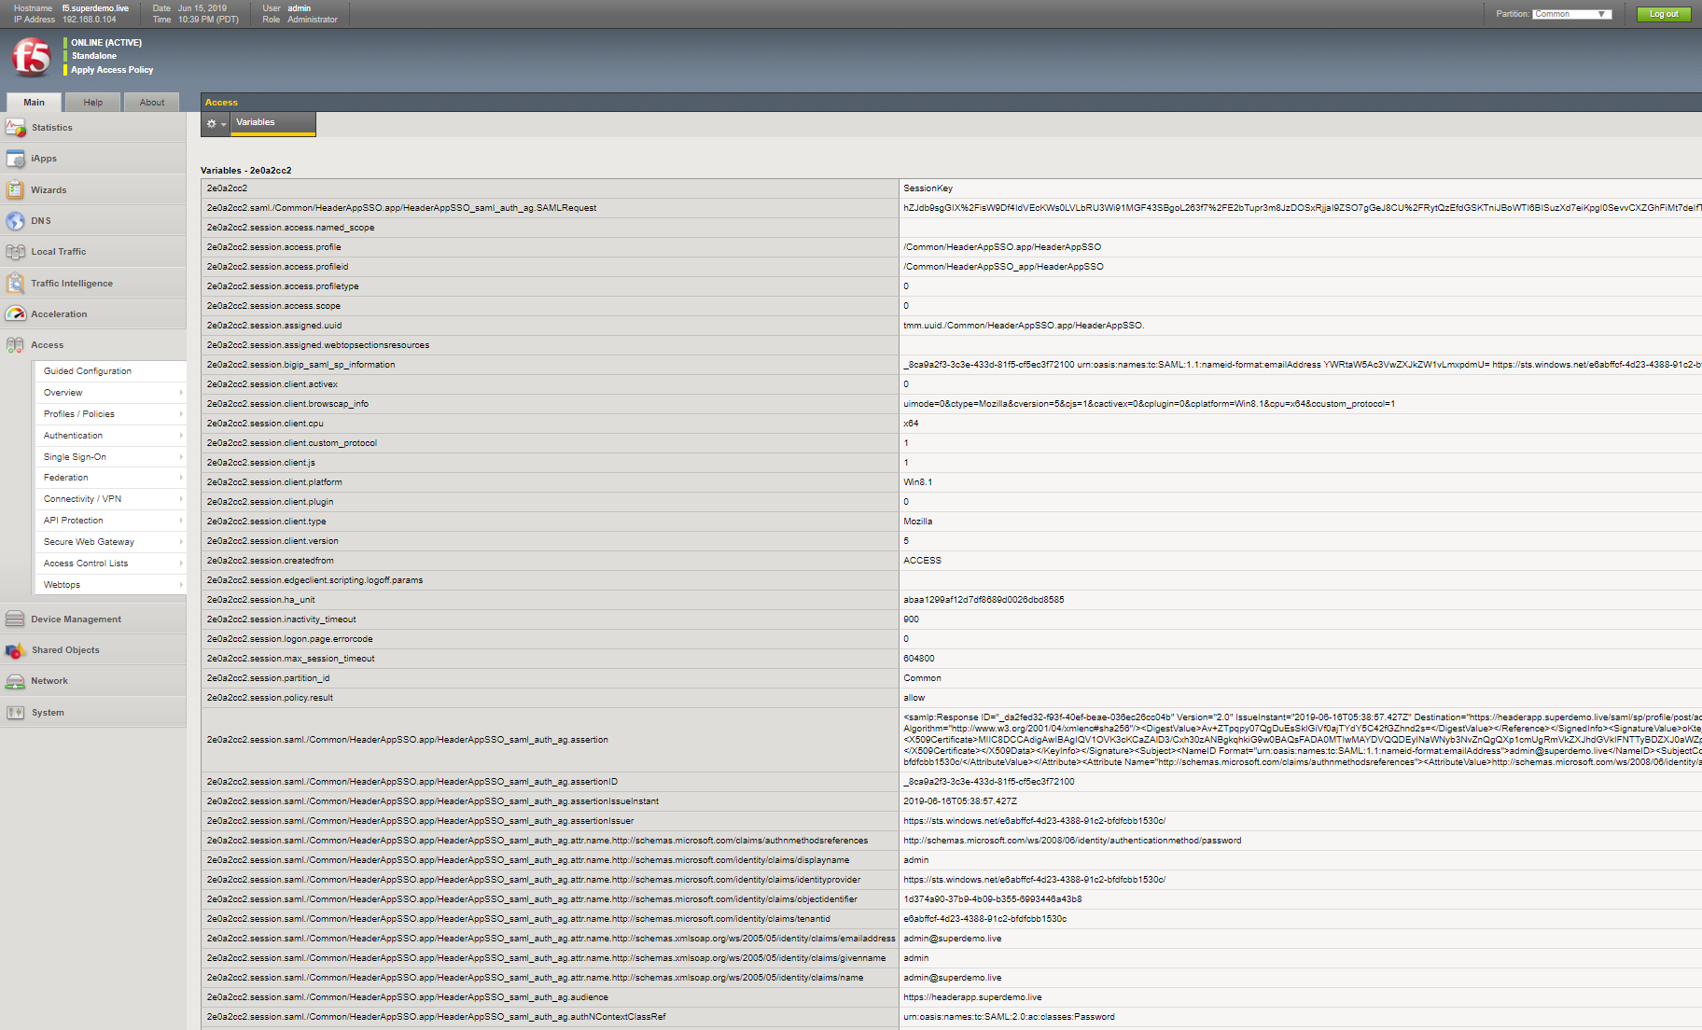

Below is the whole list of default SAML Attributes. GivenName is represented using the following string.

**session.saml.last.attr.name.http://schemas.xmlsoap.org/ws/2005/05/identity/claims/givenname**

|  |  |
| --- | --- |
| b46b6b6.session.saml.authnreq | <samlp:AuthnRequest xmlns:samlp="urn:oasis:names:tc:SAML:2.0:protocol" AssertionConsumerServiceURL="https://kerbapp.superdemo.live/saml/sp/profile/post/acs" Destination="https://login.microsoftonline.com/e6abffcf-4d23-4388-91c2-bfdfcbb1530c/saml2" ID="_b9c67faa63a224d7a63f4f3cbb09f78dc05fab" IssueInstant="2019-06-16T19:17:06.002Z" ForceAuthn="false" ProtocolBinding="urn:oasis:names:tc:SAML:2.0:bindings:HTTP-POST" Version="2.0"><saml:Issuer xmlns:saml="urn:oasis:names:tc:SAML:2.0:assertion">https://kerbapp.superdemo.live</saml:Issuer><samlp:NameIDPolicy AllowCreate="true"/></samlp:AuthnRequest> |
| eb46b6b6.session.saml.last.assertionID | _9a4e4ddd-148f-45c4-b959-f4d148172e00 |
| eb46b6b6.session.saml.last.assertionIssueInstant | 2019-06-16T19:18:03.054Z |
| eb46b6b6.session.saml.last.assertionIssuer | https://sts.windows.net/e6abffcf-4d23-4388-91c2-bfdfcbb1530c/ |
| eb46b6b6.session.saml.last.attr.name.http://schemas.microsoft.com/claims/authnmethodsreferences | http://schemas.microsoft.com/ws/2008/06/identity/authenticationmethod/password |
| eb46b6b6.session.saml.last.attr.name.http://schemas.microsoft.com/identity/claims/displayname | user0 |
| eb46b6b6.session.saml.last.attr.name.http://schemas.microsoft.com/identity/claims/identityprovider | https://sts.windows.net/e6abffcf-4d23-4388-91c2-bfdfcbb1530c/ |
| eb46b6b6.session.saml.last.attr.name.http://schemas.microsoft.com/identity/claims/objectidentifier | 90d5f0e5-8f46-4bfd-b40f-ec973d00fcb7 |
| eb46b6b6.session.saml.last.attr.name.http://schemas.microsoft.com/identity/claims/tenantid | e6abffcf-4d23-4388-91c2-bfdfcbb1530c |
| eb46b6b6.session.saml.last.attr.name.http://schemas.xmlsoap.org/ws/2005/05/identity/claims/emailaddress | user0@superdemo.live |
| eb46b6b6.session.saml.last.attr.name.http://schemas.xmlsoap.org/ws/2005/05/identity/claims/givenname | user0 |
| eb46b6b6.session.saml.last.attr.name.http://schemas.xmlsoap.org/ws/2005/05/identity/claims/name | user0@superdemo.live |
| eb46b6b6.session.saml.last.attr.name.http://schemas.xmlsoap.org/ws/2005/05/identity/claims/surname | 0 |
| eb46b6b6.session.saml.last.audience | https://kerbapp.superdemo.live |
| eb46b6b6.session.saml.last.authNContextClassRef | urn:oasis:names:tc:SAML:2.0:ac:classes:Password |
| eb46b6b6.session.saml.last.authNInstant | 2019-06-16T19:18:00.318Z |
| eb46b6b6.session.saml.last.identity | user0@superdemo.live |
| eb46b6b6.session.saml.last.inResponseTo | _b9c67faa63a224d7a63f4f3cbb09f78dc05fab |
| eb46b6b6.session.saml.last.nameIDValue | user0@superdemo.live |
| eb46b6b6.session.saml.last.nameIdFormat | urn:oasis:names:tc:SAML:1.1:nameid-format:emailAddress |
| eb46b6b6.session.saml.last.responseDestination | https://kerbapp.superdemo.live/saml/sp/profile/post/acs |
| eb46b6b6.session.saml.last.responseId | _a1eca95a-6c41-449e-bb53-1477ba106470 |
| eb46b6b6.session.saml.last.responseIssueInstant | 2019-06-16T19:18:03.070Z |
| eb46b6b6.session.saml.last.responseIssuer | https://sts.windows.net/e6abffcf-4d23-4388-91c2-bfdfcbb1530c/ |
| eb46b6b6.session.saml.last.result | 1 |
| eb46b6b6.session.saml.last.samlVersion | 2.0 |
| eb46b6b6.session.saml.last.sessionIndex | _9a4e4ddd-148f-45c4-b959-f4d148172e00 |
| eb46b6b6.session.saml.last.statusValue | urn:oasis:names:tc:SAML:2.0:status:Success |
| eb46b6b6.session.saml.last.subjectConfirmDataNotOnOrAfter | 2019-06-16T19:23:03.054Z |
| eb46b6b6.session.saml.last.subjectConfirmDataRecipient | https://kerbapp.superdemo.live/saml/sp/profile/post/acs |
| eb46b6b6.session.saml.last.subjectConfirmMethod | urn:oasis:names:tc:SAML:2.0:cm:bearer |
| eb46b6b6.session.saml.last.validityNotBefore | 2019-06-16T19:13:03.054Z |
| eb46b6b6.session.saml.last.validityNotOnOrAfter | 2019-06-16T20:13:03.054Z |

## Adding Custom Claims

As a part of your Azure Active Directory Application SAML SSO Setting, you can either modify the mappings or add additional attribute mappings.

